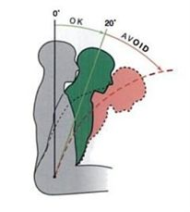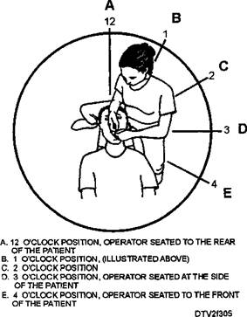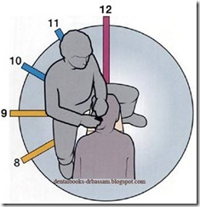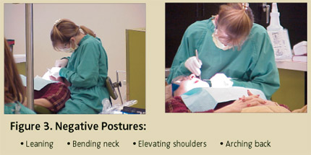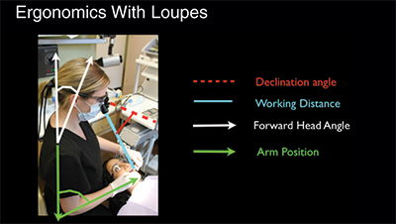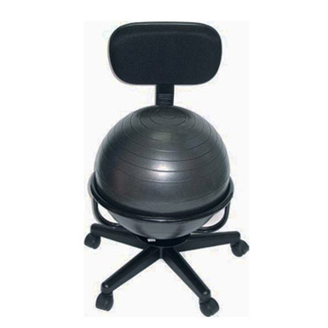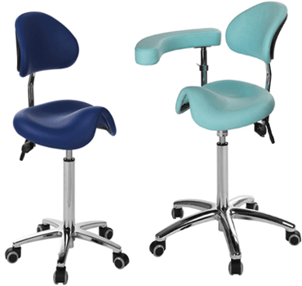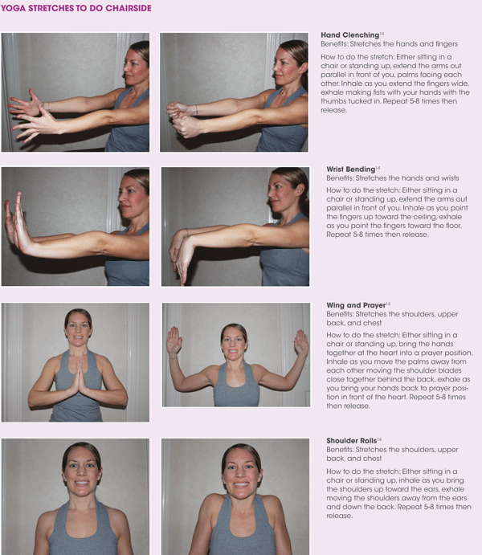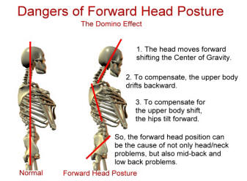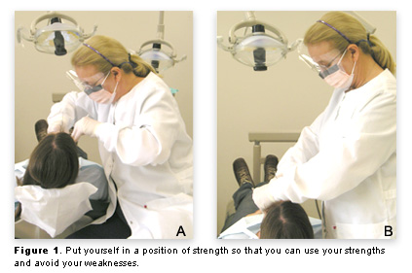

## Back to the basics

As hygienists in private practice and even in school we sometimes forget to go back to our neutral positions. Remember the building blocks of instrumentation & the sequence for establishing position? Here is a reminder: Position, grasp, mirror, finger rests, & stroke. Establishing position: Me, my patient, my equipment, my non-dominant hand, & my dominant hand.

References

[http://www.rdhmag.com/articles/print/volume-32/issue-1/features/postitioning-for-success.html](http://www.rdhmag.com/articles/print/volume-32/issue-1/features/postitioning-for-success.html" \t "_blank)

[http://www.dentistryiq.com/articles/2014/06/where-do-you-stand-with-your-dental-ergonomics.html](http://www.dentistryiq.com/articles/2014/06/where-do-you-stand-with-your-dental-ergonomics.html" \t "_blank)

[http://www.ada.org/en/publications/ada-professional-product-review-ppr/archives/2014/november/ergonomics-and-dental-practice-preventing-work-related-musculoskeletal-problems](http://www.ada.org/en/publications/ada-professional-product-review-ppr/archives/2014/november/ergonomics-and-dental-practice-preventing-work-related-musculoskeletal-problems" \t "_blank)

Warren, N. (2010). Causes of musculoskeletal disorders in dental hygienists and dental hygiene students: A study of combined biomechanical and psychosocial risk factors. *Work*, *35*(4), 441-454. doi:10.3233/WOR-2010-0981

Noh, H., & Roh, H. (2013). Approach of Industrial Physical Therapy to Assessment of the Musculoskeletal System and Ergonomic Risk Factors of the Dental Hygienist. *Journal Of Physical Therapy Science*, *25*(7), 821-826. doi:10.1589/jpts.25.821

Hayes, M. J., Smith, D. R., & Taylor, J. A. (2014). Musculoskeletal Disorders in a 3 Year Longitudinal Cohort of Dental Hygiene Students. *Journal Of Dental Hygiene*, *88*(1), 36-41.

Simmer-Beck, M., & Branson, B. G. (2010). An evidence-based review of ergonomic features of dental hygiene instruments. *Work*, *35*(4), 477-485. doi:10.3233/WOR-2010-0984

Nield-Gehrig, J. (2013). Principles of Positioning. In *Fundamentals of periodontal instrumentation and advanced root instrumentation* (7th ed., pp. 11-12). Baltimore, MD: Library of Congress Cataloging-in-Publication Data.

[http://www.rdhmag.com/articles/print/volume-32/issue-1/features/postitioning-for-success.html](http://www.rdhmag.com/articles/print/volume-32/issue-1/features/postitioning-for-success.html" \t "_blank)

[http://www.dentistryiq.com/articles/2014/06/where-do-you-stand-with-your-dental-ergonomics.html](http://www.dentistryiq.com/articles/2014/06/where-do-you-stand-with-your-dental-ergonomics.html" \t "_blank)

[http://www.ada.org/en/publications/ada-professional-product-review-ppr/archives/2014/november/ergonomics-and-dental-practice-preventing-work-related-musculoskeletal-problems](http://www.ada.org/en/publications/ada-professional-product-review-ppr/archives/2014/november/ergonomics-and-dental-practice-preventing-work-related-musculoskeletal-problems" \t "_blank)

Warren, N. (2010). Causes of musculoskeletal disorders in dental hygienists and dental hygiene students: A study of combined biomechanical and psychosocial risk factors. *Work*, *35*(4), 441-454. doi:10.3233/WOR-2010-0981

Noh, H., & Roh, H. (2013). Approach of Industrial Physical Therapy to Assessment of the Musculoskeletal System and Ergonomic Risk Factors of the Dental Hygienist. *Journal Of Physical Therapy Science*, *25*(7), 821-826. doi:10.1589/jpts.25.821

Hayes, M. J., Smith, D. R., & Taylor, J. A. (2014). Musculoskeletal Disorders in a 3 Year Longitudinal Cohort of Dental Hygiene Students. *Journal Of Dental Hygiene*, *88*(1), 36-41.

Simmer-Beck, M., & Branson, B. G. (2010). An evidence-based review of ergonomic features of dental hygiene instruments. *Work*, *35*(4), 477-485. doi:10.3233/WOR-2010-0984

Nield-Gehrig, J. (2013). Principles of Positioning. In *Fundamentals of periodontal instrumentation and advanced root instrumentation* (7th ed., pp. 11-12). Baltimore, MD: Library of Congress Cataloging-in-Publication Data.

Presented by:

Alex Holland & Lauren Brown

Lamar Institute of Technology

Dental hygiene program

Musculoskeletal Disorders in the Dental Hygienist

Our Goal

Our goal for this presentation is for you as hygienists in private practice to return to your office and be aware of the new habits you have made, and to incorporate the chair side stretches we teach you into your daily routine. Even though there are many new ergonomic appliances to help reduce the stress of MSD, patient positioning and correct positioning is still the most important factor to remember when working on your patient. At the end of the presentation ask yourself “Am I still going back to the beginning to prevent these bad habits? Are my instruments too heavy? Am I utilizing my loupes (if you have them)? Have I or noticed any of the signs and symptoms addressed?”

### **Common ergonomic Risk factors**

* Awkward positions
* Repetition
* Static postures
* Visual fatigue due to poor visualization.
* Excessive force
* Prolonged exertions
* Heavy instruments

### **Common Signs & Symptoms**

* Decreased range of motion
* Decreased grip strength
* Loss of function
* Muscle fatigue
* Numbness
* Burning
* Pain
* Tingling